# **LLM Agent Workflows: Unleashing the Power of AI Assistants**

In the rapidly evolving landscape of artificial intelligence, Large Language Model (LLM) agents have emerged as powerful tools for automating complex tasks and enhancing human productivity. This article delves into the intricacies of LLM agent workflows, exploring their potential and real-world applications.

## **Understanding LLM Agent Workflows**

LLM agent workflows refer to the process of chaining together multiple AI models or components to perform complex, multi-step tasks. These workflows leverage the strengths of different models and tools to create more capable and versatile AI systems.

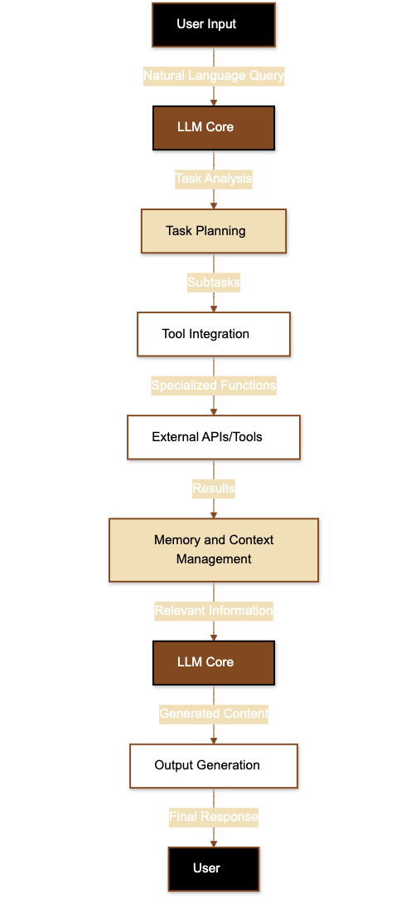**Key Components:**

1. **LLM Core**: The foundation of the workflow, typically a large language model like GPT-4 or Claude.
2. **Task Planning**: Breaking down complex requests into manageable subtasks.
3. **Tool Integration**: Incorporating external tools and APIs for specialized functions.
4. **Memory and Context Management**: Maintaining relevant information throughout the workflow.
5. **Output Generation**: Producing coherent and relevant responses or actions.

## 

## **Illustrating LLM Agent Workflows**

To better understand how these components work together, let's visualize a typical LLM agent workflow:

This diagram illustrates how a user's input is processed through various stages of the LLM agent workflow, ultimately resulting in a final response.

## **Examples of LLM Agent Workflows**

Let's explore some concrete examples of LLM agent workflows:

### **Research Assistant Workflow**

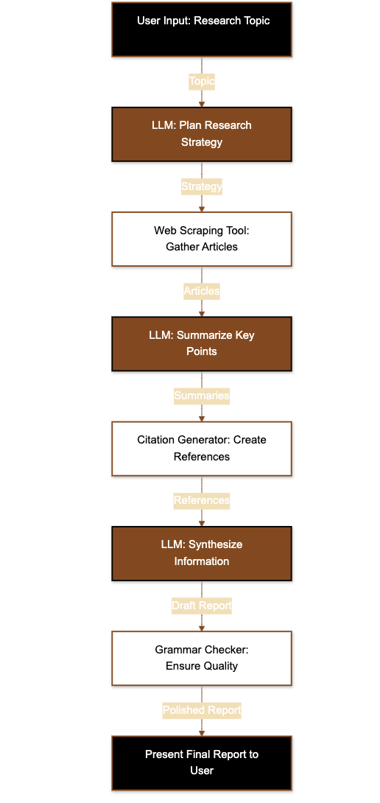

**Objective**: Compile a comprehensive report on a given topic.

**Workflow Steps**:

1. User inputs research topic
2. LLM plans research strategy
3. Web scraping tool gathers relevant articles
4. LLM summarizes key points from each article
5. Citation generator creates proper references
6. LLM synthesizes information into a coherent report
7. Grammar checker ensures writing quality
8. Final report presented to the user

### **Personal Finance Advisor Workflow**

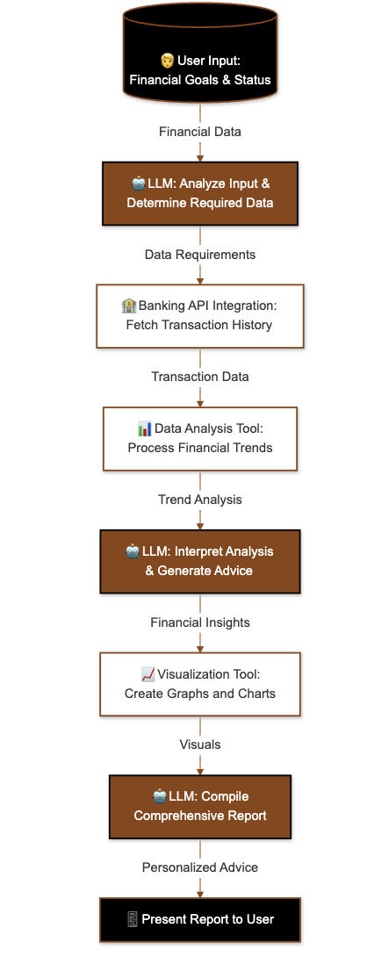

**Objective**: Provide personalized financial advice based on user's data.

**Workflow Steps**:

1. User inputs financial goals and current status
2. LLM analyzes input and determines required data
3. Integration with banking APIs to fetch transaction history
4. Data analysis tool processes financial trends
5. LLM interprets analysis and generates advice
6. Visualization tool creates graphs and charts
7. LLM compiles a comprehensive financial report
8. User receives personalized financial advice with visuals

## **Real-World Applications**

LLM agent workflows are already making significant impacts across various industries:

1. **Customer Service**: Creating advanced chatbots that can handle complex queries, access multiple databases, and seamlessly escalate to human agents when necessary.
2. **Software Development**: Automating code generation, bug fixing, and documentation by integrating with version control systems and development environments.
3. **Education**: Developing personalized learning experiences by adapting to individual student needs, accessing vast educational resources, and providing tailored explanations.
4. **Legal Research**: Streamlining case law research, contract analysis, and legal document preparation by integrating with legal databases and document management systems.

## **Conclusion**

LLM agent workflows represent a significant leap forward in AI capabilities. By combining the power of large language models with specialized tools and APIs, we can create AI assistants that are more capable, versatile, and helpful than ever before. As this technology continues to evolve, we can expect to see even more innovative applications that push the boundaries of what's possible with AI.

</antArtifact>